Task 48: Apache Kafka Fundamentals
Intern: Anas
Batch: 2026-5
Date: 23 September 2026
Introduction
Apache Kafka is a distributed event streaming platform used for high-throughput, fault-tolerant, real-time data pipelines. Originally built at LinkedIn and open-sourced.
What is Apache Kafka?
Kafka is a publish-subscribe messaging system. Producers write to topics; consumers read from topics. Messages are durably stored on disk and replicated for fault tolerance.
Why Kafka Was Created?
Traditional queues had low throughput and no replay capability. Kafka was built for millions of messages per second, replay, and horizontal scaling.
Kafka vs Traditional Queues.
Queues delete after consumption. Kafka retains messages for a configurable period, allowing multiple consumers and reprocessing.
Kafka Architecture — Core Components
Broker: A Kafka server storing messages.
Topic: A named stream of messages.
Partition: Topic split for parallelism. Ordered, immutable sequence.
Producer: Client that writes messages.
Consumer: Client that reads messages.
Consumer Group: Consumers dividing partitions for parallel processing.
Offset: Unique ID of a message within a partition.
Replication: Partition copied across brokers.
Leader/Follower: Leader handles reads/writes; followers replicate.
Complete Flow
- Producer sends message to topic.
- Kafka assigns partition (by key or round-robin).
- Leader broker appends to partition log.
- Followers replicate.
- Consumer polls, receives messages, commits offsets.
- Messages retained until retention expires.
Topics & Partitions
A topic has a name, partition count, and replication factor. Partitions enable parallel consumption — one consumer per partition per group at a time.
Partition Keys
Same key → same partition → preserved order for that key.
Kafka Producers
Configuration: bootstrap servers, serializers, acks, retries, batching, compression.
Acknowledgments:
acks=0 — no wait (fast, may lose data)
acks=1 — wait for leader only
acks=all — wait for all replicas (safe)
Kafka Consumers
Poll in a loop. Belong to a consumer group. Kafka assigns partitions. Offset commits auto or manual.
Error Handling & Retry
Failed messages retried. After N retries, sent to Dead Letter Topic (DLT).
Reliability & Fault Tolerance
Replication factor and acks=all provide durability. min.insync.replicas ensures safety.
Message Ordering
Order guaranteed within a partition, not across partitions.
Retention & Storage
Based on time or size. Log segments created, sealed, deleted. Kafka does not delete after consumption.
Kafka vs RabbitMQ
Kafka: distributed log, high throughput, replay, consumer groups.
RabbitMQ: traditional broker, lower throughput, complex routing, delete-after-consume.
Use Cases
Real-time analytics. Event sourcing. Log aggregation. Stream processing. Microservice communication.
Conclusion
Kafka is a distributed, fault-tolerant, high-throughput messaging system. Its core components form the backbone of event-driven architectures.
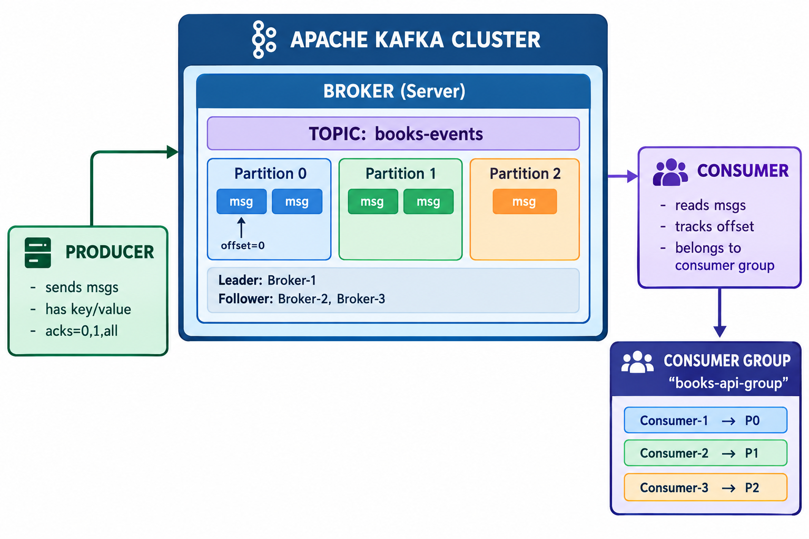
Diagram Explanation:
Producer: Client that sends messages to Kafka topics. In books-api, KafkaProducerService acts as the producer using KafkaTemplate.
Broker: A Kafka server that stores messages and serves clients. In our setup, a single broker runs in Docker on localhost:9092.
Topic: A named stream of messages. We use "books-events" as the topic for book-related events.
Partition: Each topic is split into partitions for parallelism. Our topic has 1 partition (books-events-0).
Message: A key-value pair. When a key is provided, Kafka hashes it to select the partition. Same key → same partition → ordered.
Offset: A unique sequential ID for each message in a partition. Consumers track their position by committing offsets.
Consumer: Client that reads messages from topics. In books-api, KafkaConsumerService uses @KafkaListener to receive messages.
Consumer Group: A set of consumers that divide partitions among themselves. Our group "books-api-group" has one consumer assigned to partition books-events-0.
Replication: Each partition is replicated across multiple brokers for fault tolerance. In production, replication factor is typically 3.
Leader/Follower: The leader handles reads/writes for a partition; followers replicate data. Our single-broker setup has one leader and no followers.

